

Faculty of Computer Technology
Assam down town University, Assam, India

Name | Yumnam Khristan Singh
Enrollment ID | ADTU/1/2025-28/BCAO/046
Semester | 2
Section | C
Course Title | Sorting

Assessment Report

Problems Attempted | 33
Problems Solved | 33
Accuracy (%) | 49.07
Rank | 4544349
Score | 9

Student Signature: Yumnam Khristan Singh

Contest-1
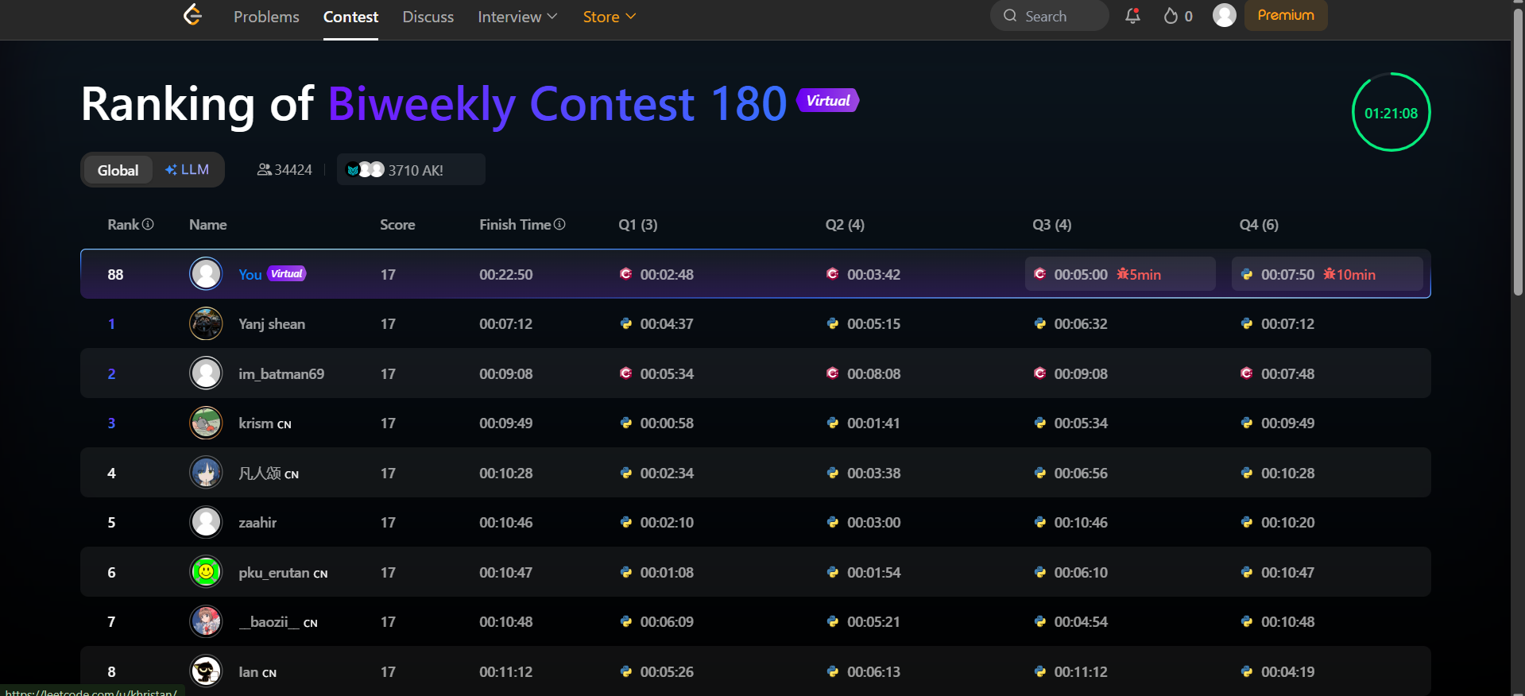

Contest-2
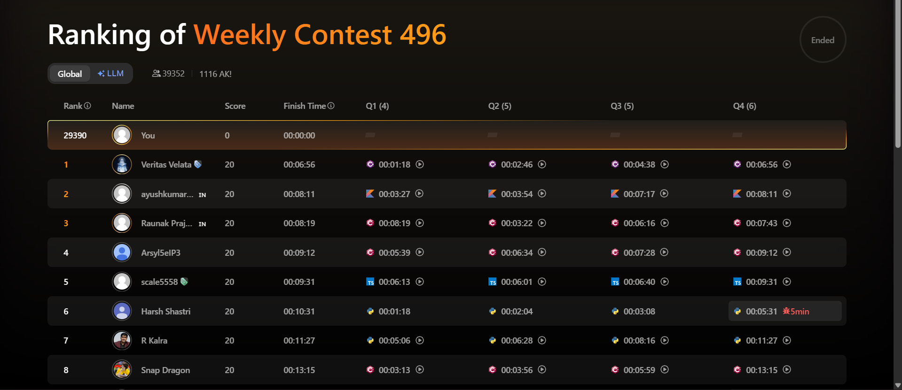

Problems:
